Automation Open Challenge 2020 – Winter Edition (Apr 2020 – Oct 2020)

Category: Best Automation Ideas

Individual’s Name and Employee Number: Ravindrareddy Madireddy and 686514

Emp Mail Id: Ravindrareddy_M

Unit: AINADEL

DC: HYDSEZUNT1

Name of the Nomination: COVID-19 Premium Relief Letter Bot

Section 1: Problem Statement –

There was sudden Upsurge in insureds availing premium relief due to COVID-19. Existing client team was not able to manually process this sudden high volume of transactions. This was leading to delays in processing customers’ requests and increasing customer complaints.

Section 2: Suggested Solution

- Our RPA Development team along with client thought about creating a UiPath Bot to expedite processing of premium relief letter for Covid-19 related work events.

- The ideation was done and owing to the urgency of the matter we decided to directly deploy the Bot in production with RAMP up strategy post the unit testing phase skipping the normal UAT/SIT route.

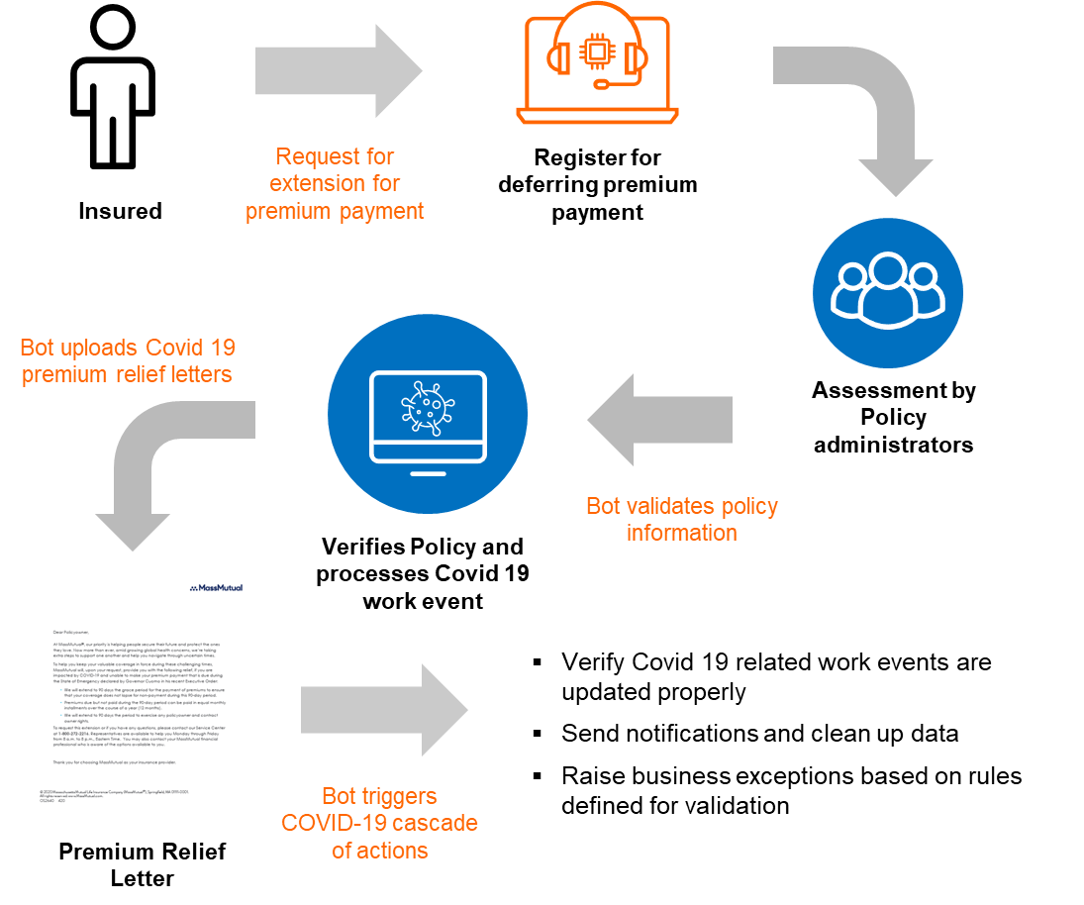 | How intelligent automation helps  - Collect data from registration for premium deferral  - Validate reasons stated  - Trigger cascade of actions  - To validate policy information  - Verify if policy is in-force  - Process Covid-19 related work event  - Upload premium relief letter  - Confirm all actions implemented  - Raise business exceptions as required

Section 3: Realized & Expected Benefits

- Higher throughput while freeing staff
- Accurate and real time update of information - 24*7 updating of information instead of 8*5 updating of information
- Policy administrator spends less time in processing the premium deferral requests
- Rule based solutions for better service, throughput, and ensures customer satisfaction
- 33,000 transactions processed till date giving us the total FTE saving of 8250 hrs. which translates to dollar savings of $250K

Section 4: POC Details

The ideation was done along with the client. Below is the design flow based on which the actual BOT was developed.
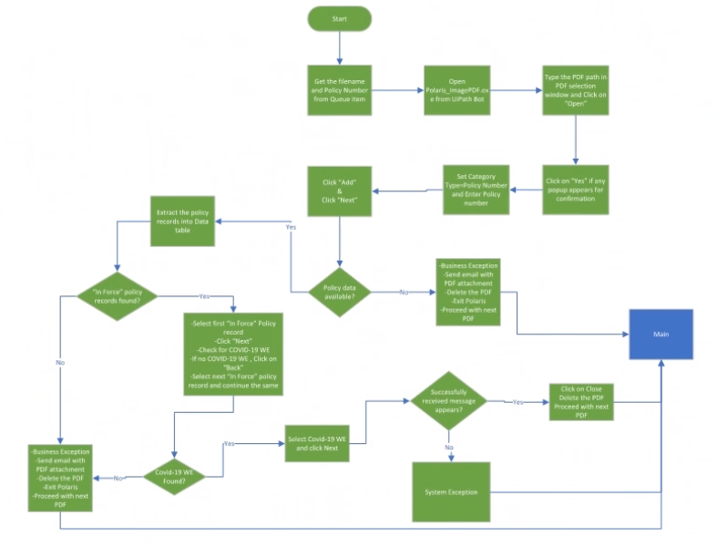

Processing Steps:
- Check LAN folder for PDFs’
- If PDF is available, Open the Polaris PDF Imaging application
Example: if we have 10 PDF’s available in LAN folder then every file should go by creation time (FIFO)
- Select the Category as Policy Number and Type in the Policy number (policy number can get from file name) and click “Next”
- If no records found, then send business exception with email (attach PDF) and delete the PDF and proceed with next PDF
- Any of In-Force status related records found then click next or else send business exception with email (attach PDF) and delete the PDF and proceed with next PDF
- Any of COVID-19 records found in next page then select that record and click Next or else send business exception with email (attach PDF) and delete the PDF and proceed with next PDF
- Check the status message, if it is successful status then click on close and proceed with next PDF or else send business exception with email (attach PDF) and delete the PDF and proceed with next PDF
- Business SME’s validated the BOT results after the GO-Live until they get the satisfactory result on the bot. This phase we call it as RAMP. During RAMP, Business SME’s load less volume of data initially and then increases the volume of load day by day. If the business SMEs feels that BOT is working as expected and is giving satisfactory result, then they will signoff otherwise they will extend the RAMP. In case of any issues found during RAMP, developer will work and fix those issues and then business SMEs will validate them again. Everyday triage meetings will happen with business SME’s, Developer and Bot support on the RAMP status. Below volume load was processed based on understanding with bot support team.

Day1 | Day2 | Day3 | Day4 | Day5 | Day6 | Day7 | Day8 | Day9 | Day10
5% | 5% | 10% | 10% | 30% | 30% | 50% | 50% | 100% | 100%

The code is on client network and Demo can be given on Teams

